Comments to the Editors and the Authors
The manuscript describes a new idea to use different orders for pressure and particle velocity components in a first-order FD scheme. The mathematical introduction of the method can be done more concise and must be written down more carefully. The new approach is clearly illustrated with two examples, but can be appreciated better if a comparison could be made with lower order methods. The salt-model example could be more focused. My comments below are geared towards a correct mathematical derivation and better focused presentation of the method.

page 3, line 22: change sentence to” acoustic wave equation in 2 dimensions can be written as”
Answer: Thanks so much for your so kindly comment. This is changed as you comment.

page 4, equation 2 and 3: the units in these equations are not correct:
Answer: Thanks so much for your so kindly comment. This is changed as you comment.
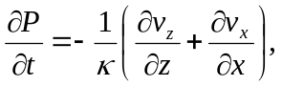 （1）
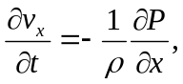 （2）
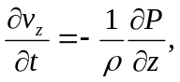 （3）

page 4, line 4: In the defined equation vx and vz are scaled (with constant _) particle-velocity components
Answer: Thanks so much for your so kindly comment. This is changed as you comment.

page 4, equation 7: this equation is not used in equation 4, 5, or 6. Why is Q introduced?
Answer: Thanks so much for your so kindly comment.. Q is introduced to give the discretization information.

page 4, line 12: not all variables in the equations are explained. Make sure that all introduced variables are explained. For example is not explained.
Answer: Thanks so much for your so kindly comment. is the time step and added in the manuscript.

page 5, line 19: leave out the word ’careful’
Answer: Thanks so much for your so kindly comment. This is changed as you comment.

page 6, line 2: You can mention here that in the provided source code the scheme is implemented in Matlab. Note that matrix shifts are typically related to a Matlab implementation and not all readers will understand this term.
Answer: Thanks so much for your so kindly comment. “We want to mention that in the provided source code the scheme is implemented in Matlab.” is added according to your comment.

page 6, line 7: The 45% improvement is related to the number of floating point operations and this does not directly relate to the simulation time. Change the sentence to ”can save about 45 percent of floating point calculations”.
Answer: Thanks so much for your so kindly comment. This is changed as you comment.

page 7, line 17: The method is introduced for 2 dimensional media and the numerical examples are all in 2D. Although it is good to know that the method also works in 3D, it is not needed to mention the 3D results explicitly in this manuscript. My proposal would be to mention that it is straightforward to extent the method to 3D and leave out all the 3D results (equation 18, Figure 1d, Figure 2d, equation 29). If you agree with my proposal then equation 20 should be rewritten for the 2D case.
Answer: Thanks so much for your so kindly comment. This is changed as you comment. Figure 1c,1d, figure 2c,2d and equation 18, 29 are deleted. Equation 20 is rewritten as
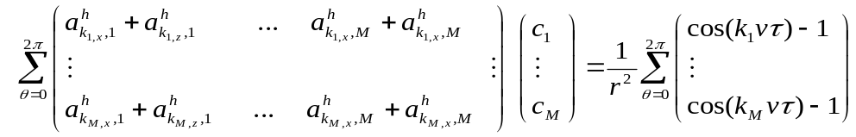

page 14, line 5, Figure 4: The star and circle are barely visible. A lighter color (white) for the star and circle will be better visible.
Answer: Thanks so much for your so kindly comment. This is changed as you comment.
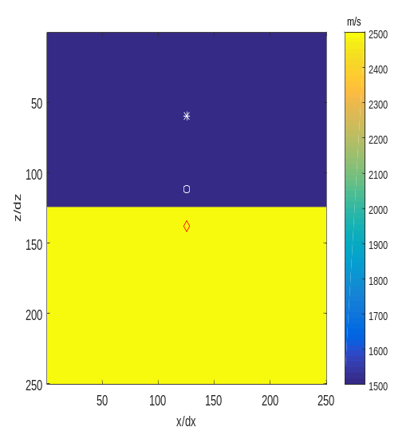
page 14, line 18, Figure 5: Can you explain why there is almost no difference between Figure 5e and Figure 5b and 5c?
Answer: I guess they are all acoustic wave-equation with the equivalent source and boundary condition, the simulation result should be same. Please note that the seismic source for the first-order acoustic wave equation and the second-order acoustic wave equation is different.

page 15, Table 1: In column 1 last row a velocity is mentioned. Can you explain in the text why you mention this velocity?

Answer: Thanks so much for your so kindly comment. A sentence is added after equation 19
“From equation 19 we could observe that the staggered-grid FD coefficient is related to r (when h and are fixed, it is related to velocity v).”

Table 1 is changed as follows so as to have an apple to apple comparison.
c₁ | c₂ | c₃ | c₄ | c₅ | c₆ | c₇
1.25477 | -0.125769 | 0.0377009 | -0.0143843 | 0.00566346 | -0.00196182 | 0.00041549
1.57866 | -0.296598 | 0.0949307 | -0.0344762 | 0.0120067 | -0.00344529 | 0.000605554

Table 1: Staggered-grid FD coefficient used to obtain the seismograms in figure 5 with the space grid interval equals 20 m and the time step equals 1.5ms and wave velocity 1500 m/s. In the first row is the staggered-grid FD coefficients used for equation (4)-(6). In the second row is the staggered-grid FD coefficients used for equations (10). The equations (11) and (12) use the simplest staggered grid FD operator and need no staggered grid FD coefficient.

page 15, Table 2: You can mention in the manuscript the explicit relation between the coefficients in the last row of Table 1 and the coefficient in Table 2 (as been given in figure5e.m) . This can help the readers to appreciate the simple linear relation, which is one of the advantages of your proposed method.
Answer: Thanks so much for your so kindly comment. Probably you are the only reviewer who read the code for more than a year. Many reviewers just say it is counter-intuitive. Thank you so much.

This sentence is added above Table 1: “It should be noted that we can obtain the normal-grid FD coefficient in Table 2 directly from the staggered-grid FD coefficient in the last row of Table 1 ([-2c₁ c₁-c₂ c₂-c₃ c₃-c₄ c₄-c₅ c₅-c₆ c₆-c₇ c₇]) based on equation 13. ”

page 18, line 5: Can you mention the reduction in simulation time in seconds?
Answer: Thanks so much for your so kindly comment. This sentence is added: “With the traditional staggered-grid FD scheme, the simulation time is 781 seconds. With the simplified staggered-FD grid scheme, the simulation time is 428seconds.”

page 19, Figure 7: The differences between the salt-model results are hard to see in the grey-scaled
plots. My advise would be to use wiggle traces and select a limited number of them (10-15) for each shot panel, or use only selected overlay traces as in Figure 8 and Figure 9d, or subtract a reference result from each of the FD results and show only the difference.
Answer: Thanks so much for your so kindly comment. Subtraction is added. Figure 9(c) and figure 10(c) is added to show the difference between the traditional method and the simplified method.

An even more convincing comparison of the proposed method can be made with lower order operators in equation (10). For example with M=2. The computational time will be reduced even
further
Answer: Thanks so much for your so kindly comment. This is contrary to your suggestion. The bigger the M, the more suitable the proposed simplified method. However, it is not efficient to use too large M. The simulation time save is 1-(1+1/M)/2. The bigger the M, the more simulation time saved.

Not all figures can be reproduced with the provided code on GitHub. To reproduce the Salt model examples the velocity file (vv) is needed, but not included. It would also be very useful if the Matlab file to compute the optimised coefficients is provided. Then the readers can experiment with different combinations of orders in P and Vx;z calculations
Answer: Thanks so much for your so kindly comment. vv.mat is added as you suggested. The code to calculate the FD coefficient is also added in Github.

We can calculate more than 3000 FD coefficient within 1 second ( I want to mention when v and h and tau are changed, k=linspace(1/50,0.8*pi/h,M); 0.8 should also be changed. 0.8 is the wavenumber range we need to optimize).

clear;
clc
close all

load ('vv.mat') % then we obtain velocity model c

M=7;

AA=zeros(M,M);
b=zeros(M,1);
dt=0.001;

v=1500;
h=20;
k=linspace(1/50,0.8*pi/h,M); %%%%%% it should be changed 0.8 as other value when v tau h changed

coeffJune28=zeros(floor(max(max(c))- min(min(c)) )+1, M); % range from 1486 to 4800
tic;
iii=1;

for v= floor(min(min(c))):floor(max(max(c)))
for ii=1:M
for kk=1:5
xita=(kk-1)*pi/16;
for jj=1:M
AA(ii,jj)=2*cos(jj*k(ii)*h*cos(xita))-2*cos((jj-1)*k(ii)*h*cos(xita))...
+2*cos(jj*k(ii)*h*sin(xita))-2*cos((jj-1)*k(ii)*h*sin(xita)) +AA(ii,jj);
end
b(ii)=1/(v^2*dt^2/h^2)*(2*cos(v*k(ii)*dt)-2)+b(ii);
end
end

coeffJune28(iii,:)=AA\b;
iii=iii+1;
end
toc
save('Figure7bCoeff.mat')

Hopefully, my comments and remarks can be used to improve the manuscript and are helpful to get it
published soon.

Thank you so much for such nice comment.

Reviewer #2: This paper presents a finite-difference method for linear wave equations. To save computation cost, the authors approximated the spatial derivatives in the particle velocity equations using a two-point central finite-difference scheme. The key question is whether there is any accuracy loss by using the short finite-difference operators. The authors tried very hard to argue that there is no accuracy loss. I am not convinced for the following reasons.

1. The comparisons throughout the paper are not apple to apple. The proposed scheme belongs to the category of optimized scheme in time-space domain. However, the dispersion curves are compared with Taylor expansion based scheme, which is not a fair comparison. In the layered model example, the seismograms are compared with Taylor expansion based scheme and optimized scheme in space domain, which are not fair either. To make fair comparisons, I strongly recommend the authors compare the proposed scheme with the one in Wang et al. (2014) for dispersion, stability and numerical examples. All other comparisons are not relevant and thus can be removed.
Answer: Thank a lot to your comment. We revised the paper as you suggested and deleted other comparisons.
For the layered velocity model, the comparison to Chu and Stoffa (2012) method is deleted. We replace the comparison with Liu’s method with comparison to our previous method (Want et al, 2014).
For the salt model, we only compare the proposed simplified staggered-grid FD scheme with our previous method (Want et al, 2014) and changed these figures.

2. The authors seem to argue that the new scheme has no accuracy loss in all circumstances despite the fact that many terms are thrown away. This is very counter-intuitive. I recommend the authors think deeper and provide an intuitive explanation. Alternatively, it will make the readers feel much more convinced if the authors can provide a situation in which the new scheme is slightly less accurate than the full-blown one in Wang et al. 2014. Again, it is hard to believe that there is a free lunch.
Answer: Thank a lot to your comment. Yes, it is the most common question when I presented the method to other people. My answer always is please having a try.
We just make sure it works for the situation in the paper. Maybe for elastic wave equation, it does not work.
A simple version of the idea is accepted and published on Exploration Geophysics and is easier to reproduce because in the space domain there is only one set of FD coefficient.
http://www.publish.csiro.au/EG/EG17088
It is more than a year since we found this method is useful (This manuscript is under review for half a year). The simplified staggered-grid FD scheme works because:
- The proposed first-order staggered-grid FD scheme is equivalent to the second-order normal-grid FD scheme:
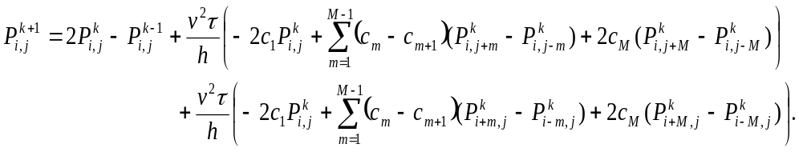(13)
The simulation result of the first order wave equation and the second order wave equation is the same, so it should be more natural that they have the same simulation time(As you know, it takes almost double time to use the first order wave equation at present).
- There is an same number of unknowns in the proposed method compared with the traditional method. So they should have the same capability to preserve the dispersion relation.
- It is not a free lunch. We just pay the right price. We pay too much previously.
We use double time for the first-order acoustic wave-equation for more than 40 years. This is double pay (4 spatial derivatives VS 2 spatial derivatives). With the proposed method, we use same time for the first-order acoustic wave-equation and the second-order acoustic wave-equation. This is the right price.

As we say, this research is completely reproducible with Matlab source code shared at Github. When I am interested in or doubting someone’s work, I will try to reproduce them to see whether it is true. I really wish you can spend some time to reproduce the result. It is so easy.

3. There is no definition of "traditional staggered-grid scheme". How are the coefficients in equations (4-6) determined in the "traditional" scheme?
Answer: Thank a lot to your comment. Hereafter, we call the staggered-grid FD scheme in equations 4-6 the traditional staggered-grid FD scheme.
（4）
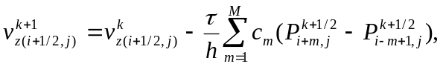 （5）
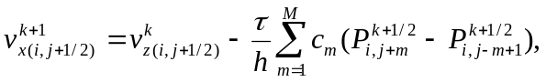 （6）
where
（7）
M is the length of the FD operator, c_{m} are the staggered grid FD coefficients, h is the spatial-grid interval and is the time step. Hereafter, we call the staggered-grid FD scheme in equations 4-6 the traditional staggered-grid FD scheme.
The coefficient in the traditional staggered-grid FD scheme are obtained using the method in our previous work (Wang et al, 2014)
4. In equation (20), how are the angles \phi and \theta discretized?
Answer: Thank you so much for your help. According to reviewer 1’s comment, we delete the 3D situation. In 2D,

5. Equation (13), please check notations.
Answer: Thank you so much for your help and pointing this error. Equation 13 is changed as
(13)
There are two places are changed: (1) P_{x} should be P; (2) 2c₁ should be -2c₁ .

Last but not least, the language used in the article is emotional or defensive at the very least, e.g., "Do not use old mind" on Page 7. I don't think strong language helps in scientific publication. Please focus on providing strong evidence and coherent lines of thoughts.

Answer: Thank you so much for your help. These words are deleted from the manuscript. If you find any language which is inappropriate, please point out for us. Thanks a lot!

https://github.com/LongyanU/JCP

